RESUME

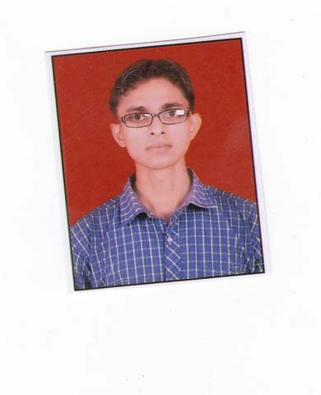
ROCKY KUMAR
E-Mail: rockyrpsht@gmail.com, rockysinghias@gmail.com
Mobile: +91-9818240557/7895461653(R)
Summary
- B.A. from Devta Mahavidyala ,Morna , Bijnor (MJP Barilly) in 2015
- A dynamic individual with highly motivated & positive attitude towards life.
- Exceptionally organized with a track academic record that demonstrates creativity and shows ability to take initiatives for achieving set goals.
- Possess exceptional team spirit thereby helping in easy achievement of organizational & personal goals.
- An effective communicator with excellent relationship building & interpersonal skills.

- SCHOLASTICS

- Bachelor of Art – in 2015
- Devta Mahavidyala ,Morna , Bijnor (MJP Barilly) Secured 56.25%
- Intermediate Certificate in 2012
Shr. Babu Singh S. Inter College Jirolly Aligarh from U.P. Board. Secured 62 %
- High School Certificate in 2009
- Dhampur Public School Dhampur, Bijnor from U.P. Board Secured 50%
Academic Credentials

- 1 year I energizer Pvt. Ltd
Noida Secter-60
Block-A-37
1 year Net Incubil Pvt. Ltd
Noida Secter-64 Block-38K

IT Skills
- Well versed with:

- Windows XP/7

- MS- Office 2007
- MS- Office 2010
- MS -Excel
Strengths and Hobbies
- Ability to work in team.
- Effective Time Management and strong technical skill.
- Enthusiastic and committed to excellence in my work
- Self Starter and Ideas driven attitude.

Hobbies Net Surfing, , Travelling..

Personal Dossier
Father’s Name : Mr. Bharat Singh

Date of Birth : 10 June 1992

Nationality : Indian

Marital Status : Single

Permanent Address : Village- Basawanpur, Post- Nehtour, Tehsile- Dhampur , Distric - Bijnor Uttar Pradesh

Pin Code : 246733

Present Address : Noida, Sector-66
Pin Code : 201301

Linguistic Abilities : Hindi & English.

.

DECLARATION:
I declare that the information and facts stated above are true to the best of my knowledge and belief.

Place: Bijnor ROCKY KUMAR
Date:

